FALL 2018 Newsletter

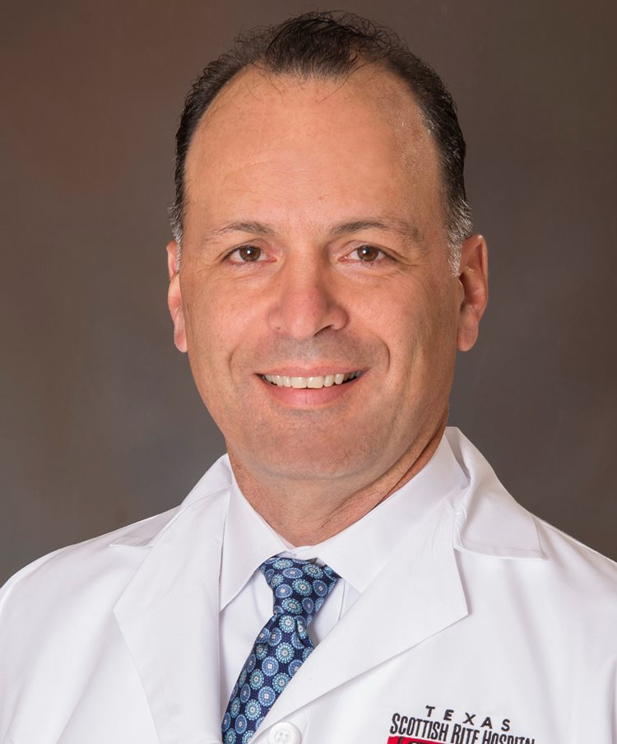

Dr. Sucato

|  |  |  |
| --- | --- | --- |
|  | | |
|  | | |
|  |  |  |
| C:\Users\drainc\AppData\Local\Temp\Millis photo.jpg  **Surgeon Spotlight**  Presidential Guest Speaker at 2018 Pediatric Orthopaedic Society of America (POSNA)  Dr. Michael Millis, one of the founding members of ANCHOR and credited surgeon for our name, is a graduate of Harvard Medical School and the Harvard Combined Orthopaedic Residency Program. Following a fellowship with Professor Heinz Wagner, in Germany, he has pursued a career-long interest in developmental hip conditions and their evolution through adolescence and adulthood, with a particular interest in hip preservation surgery. He was the Founding Director of the Adolescent and Young Adult Hip Unit at Boston Children Hospital and is Professor of Orthopaedic Surgery at Harvard Medical School. Dr. Millis received the Pro Maximis Meritis Award from EPOS in 2017. | C:\Users\drainc\Desktop\ANCHOR Surgeon Photos\TSC_Dr_Henry_Ellis_1500x1808.jpg  Dr. Ellis  C:\Users\drainc\AppData\Local\Temp\Podeszwa photo.jpg  Dr. Podeszwa  **ANCHOR Site Spotlight**  Texas Scottish Rite Hospital For Children is dedicated to advancing treatment methods, conducting pioneering research and educating health care professionals locally and abroad to serve the commitment of giving children back their childhood. The Texas Scottish Rite Hospital ANCHOR surgeons will host the annual ANCHOR meeting in Dallas on November 18-19, 2018. | C:\Users\drainc\AppData\Local\Temp\DSC_1003-edit 1.jpg  **Study Spotlight**  Under the direction of Dr. John Clohisy and Dr. Jeffrey Nepple, the ANCHOR Group will launch a new research project in January 2019 that will focus on the contemporary surgical treatment for Femoroacetabular Impingement (FAI). Washington University School of Medicine will serve as both the Coordinating and Data Management Center for this study.  More exciting details to come in our Fall Newsletter |
|  |  |  |

**A**cademic **N**etwork of **C**onservational **H**ip **O**utcomes **R**esearch

 FALL 2018 Newsletter

**Highlighted ANCHOR Study**: The Journal of Bone and Joint Surgery): Table 1 (below) provides patient characteristics from this important study -[**http://dx.doi.org/10.2106/JBJS.15.00798**](http://dx.doi.org/10.2106/JBJS.15.00798)**.**

Future studies with this cohort will focus on mid-term follow-up and radiographic predictors of clinical outcomes.



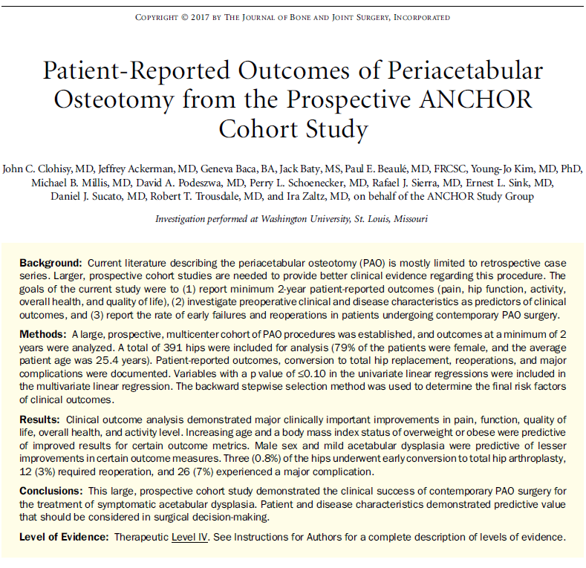

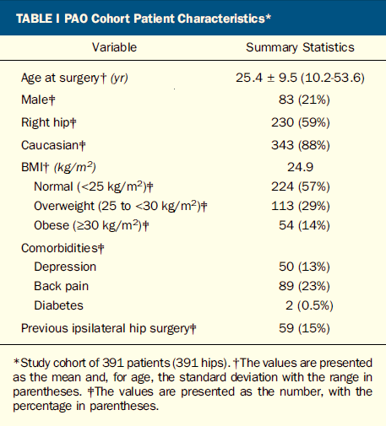

**ANCHOR GROUP Facts**

* At present, 27 orthopaedic surgeons at 15 different institutions make up the ANCHOR Group
* At present, our data repository stores patient reported outcomes from over 3,500 participants
* Our work has been supported, in part, by the Curing Hip Disease Fund, ANCHOR Research Fund, International Hip Dysplasia Institute, Washington University ICTS, an NFL grant, NIH R13, The Hip Society and industry grants (Zimmer Biomet; Smith and Nephew).

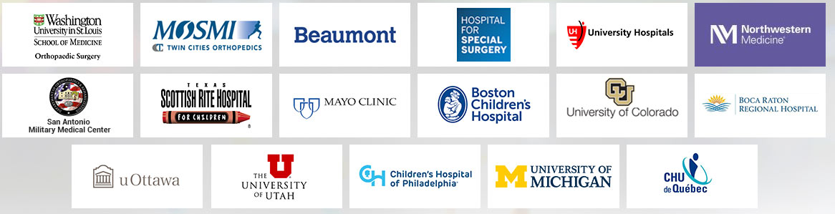

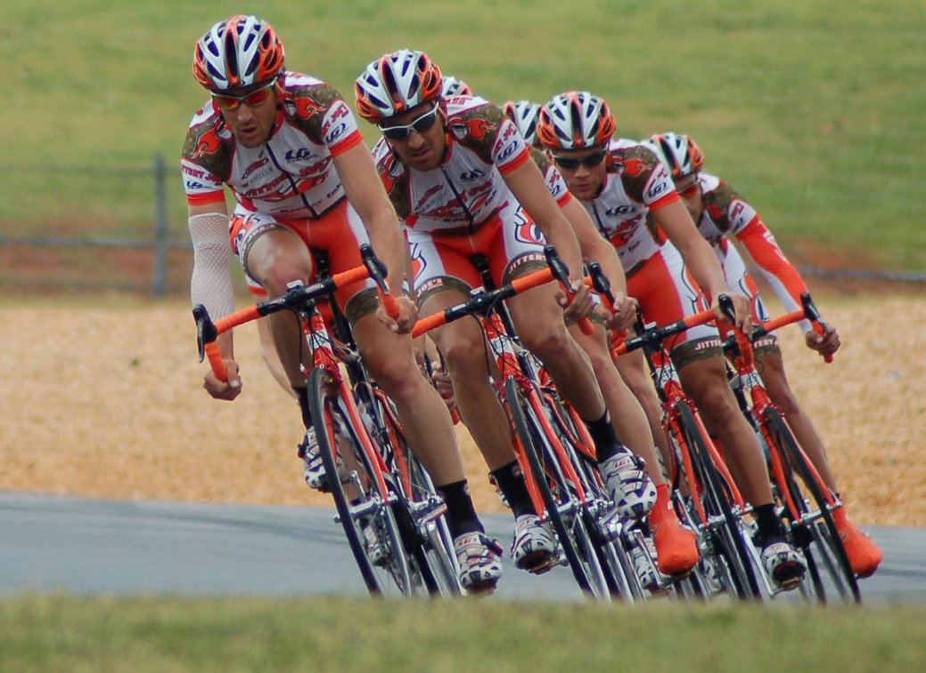

**ANCHOR** is a multicenter clinical research group focused on the investigation of adolescent and young adult hip disorders.

